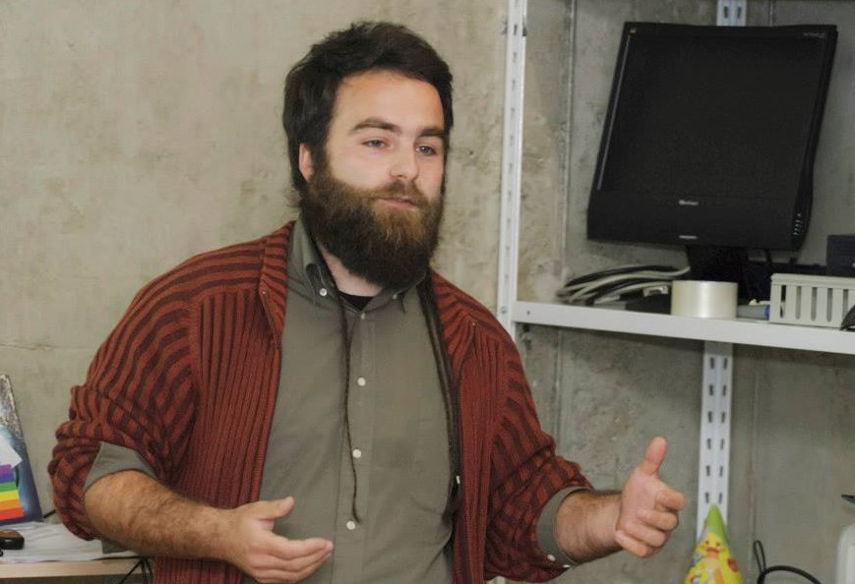
Aleksandar Novović is a politologist and social and environmental activist from Montenegro. Part of his activism is oriented in a field of informal and formal environmental education in schools. Through his work he established first School garden in Montenegro and he is co-author of School garden education program called School Garden – Integral Classroom. Also, he is co-founder of the first Urban Garden Community in Montenegro called Bašta Ekologika.

